
DAYANAND SAGAR UNIVERSITY
Devarakaggalahalli, Harohalli Kanakapura Road, Dt, Ramanagara, Karnataka 56211

Artificial intelligence MINI PROJECT
TOPIC:-Image processing

From:- Venkat durga sai D(ENG22AM0067)
Vishwas N (ENG22AM0069)
Chriang L Gowda(ENG22AM0086)

TO:- Prof. Pradeep Kumar K
Dept. of CSE (AIML)

Place:-Bangalore

Introduction:-
Image processing is a multidisciplinary field that involves the manipulation and analysis of digital images to extract meaningful information or enhance their visual quality. It plays a crucial role in various applications, ranging from medical imaging and remote sensing to computer vision and entertainment.
What is an image processing?
Image processing is the process of transforming an image into a digital form and performing certain operations to get some useful information from it. The image processing system usually treats all images as 2D signals when applying certain predetermined signal processing methods.
Components of image processing:-
1.Image representation:- Digital images are typically represented as a grid of pixels, where each pixel contains information about the color or intensity at that point.
Grayscale images have one channel (intensity), while color images have multiple channels (e.g., red, green, blue).
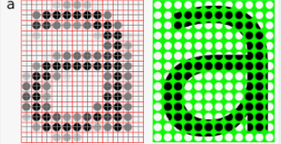
2. Image Enhancement:- Techniques to improve the visual appearance of an image, such as adjusting brightness, contrast, and sharpness.Histogram equalization is a common method for improving contrast by redistributing pixel intensities.
3.Filtering:- Convolution is a fundamental operation in image processing. Filters (kernels) are applied to images for operations like blurring, sharpening, and edge detection.
4.Image Transformation:- Geometric transformations, such as scaling, rotation, and translation, can be applied to images.Fourier transform is used for frequency domain analysis, enabling operations like filtering and compression.
5.Image Segmentation:- Dividing an image into meaningful parts or regions.Common techniques include thresholding, edge detection, and clustering algorithms.
6.Object Recognition:- Identifying and classifying objects within an image.Machine learning, particularly deep learning, has been successful in image classification tasks.
7. Feature Extraction:- Extracting relevant information from an image for analysis.Features can include color, texture, shape, and more.
8.Morphological operation:- Operations that analyze and process the shapes of objects in images.Erosion, dilation, opening, and closing are common morphological operations.
9.Image Compression:- Reducing the storage space required for an image while maintaining acceptable quality.JPEG, PNG, and GIF are popular image compression formats.
10.Image Restoration:- Recovering an image from degraded or noisy versions.Techniques like Wiener filtering and total variation regularization are used.
Tools for image processing:-
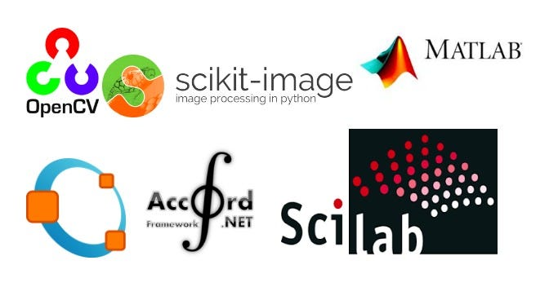
Image processing in medical field
Code to access the image
import matplotlib.pyplot as plt
scrrenshot=plt.imread("/Screenshot 2023-12-06 193654.png")
plt.imshow(scrrenshot)
plt.axis("off")
plt.show()

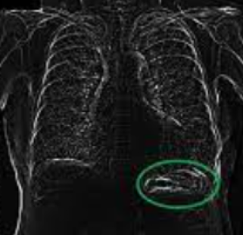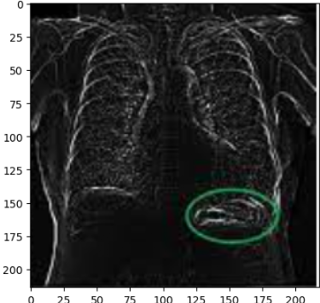
or
import cv2
import numpy as np
from google.colab import files
from io import BytesIO
from PIL import Image
uploaded = files.upload()# Upload an image file
image_path = list(uploaded.keys())[0] # Read the uploaded image
image_data = uploaded[image_path]
image = cv2.imdecode(np.frombuffer(image_data, np.uint8), cv2.IMREAD_COLOR
# Display the original image
Image.fromarray(cv2.cvtColor(image, cv2.COLOR_BGR2RGB))

Code to filtering an image
import cv2
import numpy as np
import matplotlib.pyplot as plt

# Read the image
image = cv2.imread("/content/Screenshot 2023-12-06 193654.png")

# Define a filter kernel (e.g., a simple 3x3 averaging filter)
kernel = np.ones((5,5), np.float32) / 9.0

# Apply the filter to the image using convolution
filtered_image = cv2.filter2D(image, -1, kernel)

# Display the original and filtered images using matplotlib
plt.subplot(121), plt.imshow(cv2.cvtColor(image, cv2.COLOR_BGR2RGB)), plt.title('Original Image')
plt.subplot(122), plt.imshow(cv2.cvtColor(filtered_image, cv2.COLOR_BGR2RGB)), plt.title('Filtered Image')
plt.show()
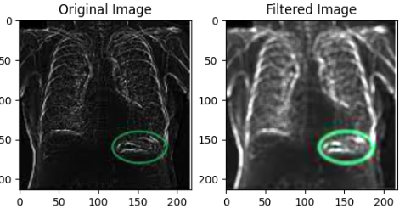

Application of image processing:-
- Computer Vision: Applying image processing techniques to enable machines to interpret and understand visual information.
Object detection, image recognition, and facial recognition are examples of computer vision applications.

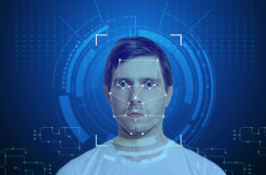
2.medical imaging:- Image processing plays a crucial role in medical applications, including CT scans, MRI, and X-ray analysis.
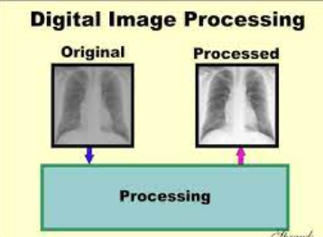
3.Remote sensing:-Analyzing images captured from satellites or other remote platforms for applications such as environmental monitoring and land use classification
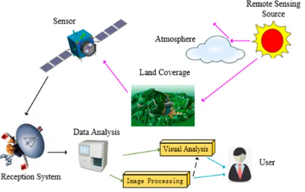
Advantages of AI image processing:
1. Faster and smarter: AI can handle images quicker and better than humans.
2. No bias: AI is always fair and objective, unlike humans.
3. Finds hidden patterns: AI can see things humans miss in images.
4. Decisions made in real-time: AI can analyze images and act instantly.
5. Better customer experience: AI makes shopping and interacting with images easier.
6. Saves money: AI reduces costs by automating tasks and optimizing resources.
7. Everyone can use it: AI image processing is becoming accessible to everyone.
Examples of how AI image processing helps us:
Doctors: AI finds diseases in scans earlier, saving lives.
Cars: AI helps self-driving cars see and make safe decisions.
Factories: AI finds problems with products before they're sold.
Security: AI cameras spot suspicious activity and alert police.
Farmers: AI helps farms grow more food with less waste.
Disadvantages of image processing:
1. Expensive to set up: Needs fancy computers and programs, not for everyone.
2. Need a brainiac: Requires special skills to use and understand.
7. Makes us lazy: We might stop thinking for ourselves.
8. Takes away jobs: Can replace people with machines.
9. Hard to understand: Like a foreign language, difficult to interpret.
Can be misused: Bad people can use image processing to create fake images and spread lies.
7. Makes people lazy: If we rely too much on image processing, we might stop thinking for ourselves.
Conclusion:-
As we know that image processing become one of important thing my life.From this we had an advantages and disadvantages also that’s why we use were its required (medical,drug detection,drunk and drive test).If we use for unwanted things than it makes man lazy .

